Lab - Windows Task Manager

# Objectives

In this lab, you will explore Task Manager and manage processes from within Task Manager.

Part 1: Working in the Processes tab

Part 2: Working in the Services tab

Part 3: Working in the Performance tab

# Background / Scenario

The Task Manager is a system monitor program that provides information about the processes and programs running on a computer. It also allows the termination of processes and programs and modification of process priority.

# Required Resources

* A Windows PC with internet access

# Instructions

## Working in the Processes tab

* + 1. Open a command prompt and a web browser.

Microsoft Edge is used in this lab; however, any web browser will work. Just substitute your browser name whenever you see Microsoft Edge.

* + 1. Right-click the Task bar to open **Task Manager**. Another way to open the Task Manager is to press **Ctrl-Alt-Delete** to access the Windows Security screen and select **Task Manager**.
    2. Click **More details** to see all the processes that are listed in the Processes tab.
    3. Expand the Windows Command Processor heading.

### Question:

What is listed under this heading?

Type your answers here.

* + 1. There are three categories of processes listed in the Processes tab: Apps, Background processes, and Windows processes.
* The Apps are the applications that you have opened, such as Microsoft Edge, Task Manager, and Windows Command Processor, as shown in the figure above. Other applications that are opened by the users, such as web browsers and email clients, will also be listed here.
* The Background processes are executed in the background by applications that are currently open.
* The Windows processes are not shown in the figure. Scroll down to view them on your Windows PC. Windows processes are Microsoft Windows services that run in the background.

Some of the background processes or Windows processes may be associated with foreground processes. For example, if you open a command prompt window, the Console Window Host process will be started in the Windows process section, as shown below.

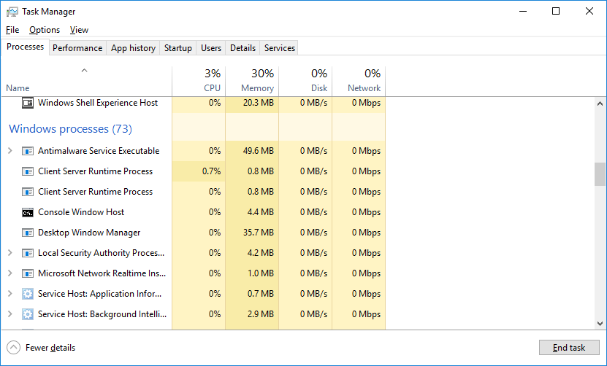

* + 1. Right-click Console Window Host and select **Properties**.

### Question:

What is the location of this filename and location of this process?

Type your answers here.

* + 1. Close the command prompt window.

### Question:

What happens to Windows Command Processor and Console Window Host when the command prompt window is closed?

Type your answers here.

* + 1. Click the Memory heading. Click the Memory heading a second time.

### Question:

What effect does this have on the columns?

Type your answers here.

* + 1. Right-click on the Memory heading, and then select **Resource values** > **Memory** > **Percents**.

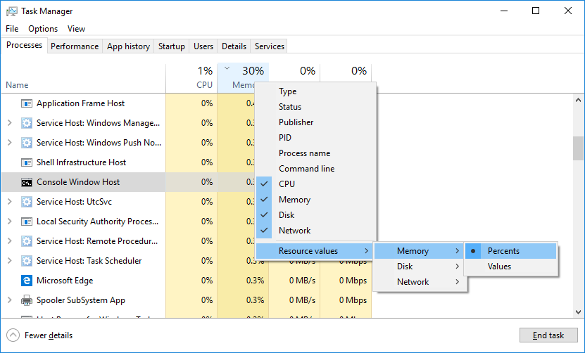

### Questions:

What affect does this have on the Memory column?

Type your answers here.

How could this be useful?

Type your answers here.

* + 1. In the Task Manager, click the **Name** heading.

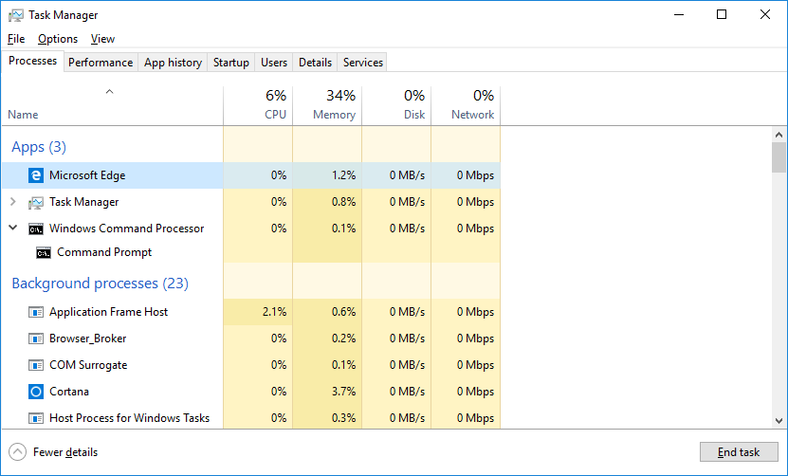

* + 1. Double-click the Microsoft Edge.

### Question:

What happens?

Type your answers here.

* + 1. Return to the Task Manager and right-click Microsoft Edge. Select **End task**.

### Question:

What happens to the web browser windows?

Type your answers here.

## Working in the Services tab

In the Task Manager window, click the **Services** tab. Use the scroll bar on the right side of the **Services** window to view all the services listed.

### Question:

What statuses are listed?

Type your answers here.

## Working in the Performance tab

* + 1. In the Task Manager window, click the **Performance** tab.

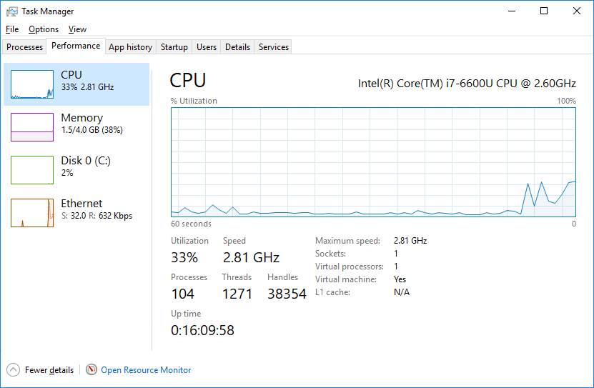

### Questions:

How many threads are running?

Type your answers here.

How many processes are running?

Type your answers here.

* + 1. Click the **Memory** in the left panel of the **Performance** tab.

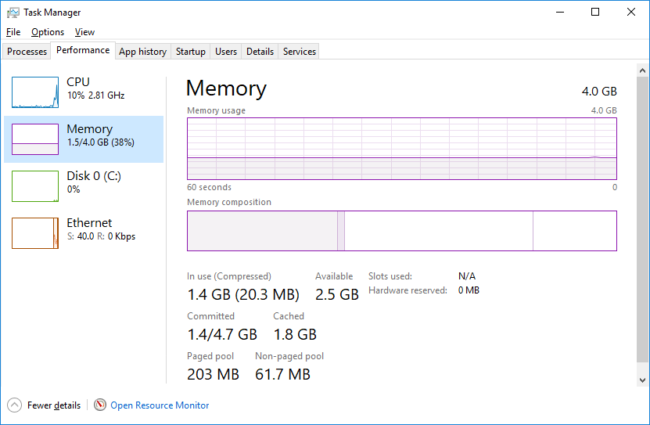

### Question:

What is the total physical memory (MB)?

Type your answers here.

What is the available physical memory (MB)?

Type your answers here.

How much physical memory (MB) is being used by the computer?

Type your answers here.

* + 1. Click the **Ethernet Chart** in the left panel of the **Performance** tab.

Screenshot of the Task Manager showing the
results of selecting the Ethernet chart. 

### Questions:

What is the link speed?

Type your answers here.

What is the IPv4 address of the PC?

Type your answers here.

* + 1. Click **Open Resource Monitor** to open the Resource Monitor utility from the Performance tab in Task Manager.

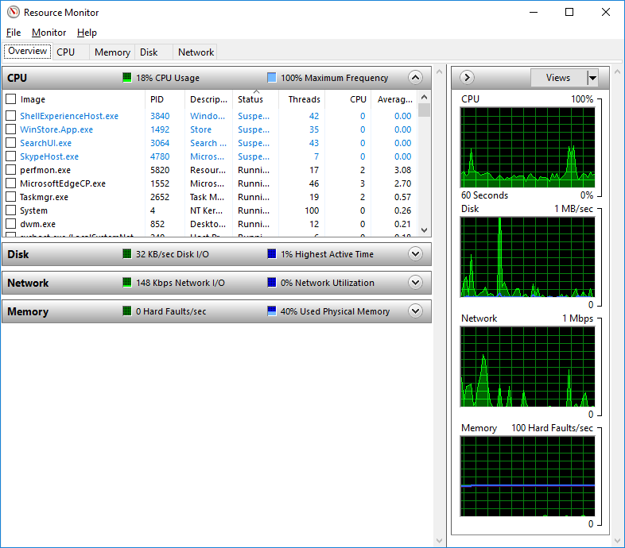

# Reflection Question

Why is it important for an administrator to understand how to work within the Task Manager?

Type your answers here.

End of document